**Test Document for CR634-GH321-IR Extension Data for Accounts**

New Report “Print IR Extension” tfisg4405m000 is created, testing screenshots are below:

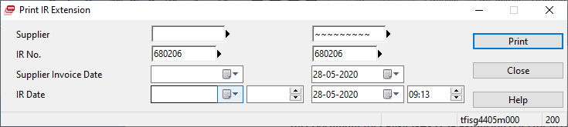

Testing in IR No. 680206:

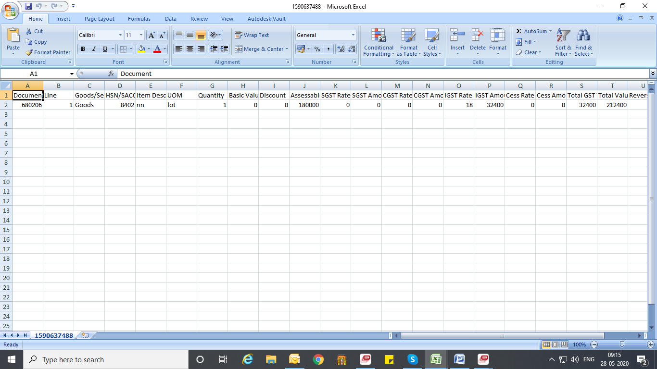

Now testing by Supplier Code - 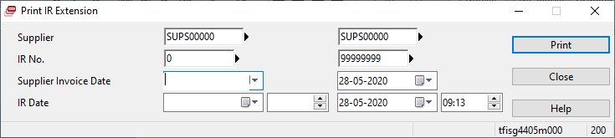

Result:

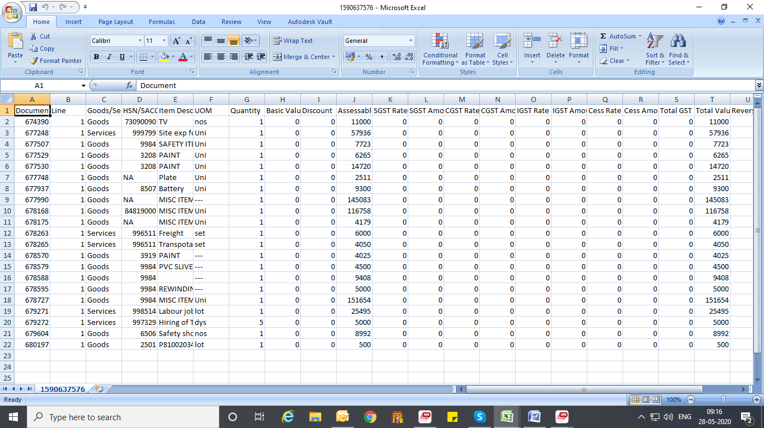

Now, testing for tfisg4105m100(IR Extension)

When opening this session from session tfisg1500m100 message "Please maintain the IR extension first" is not coming.